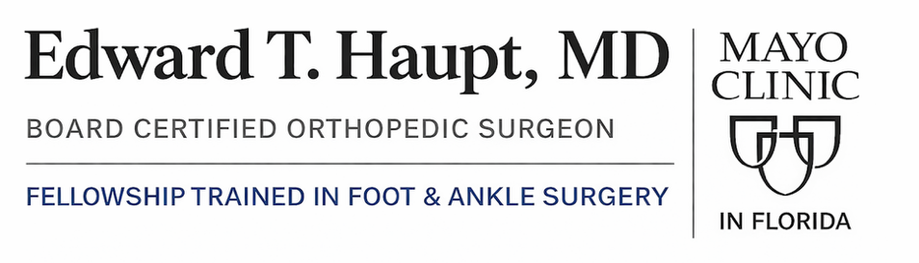


Mayo Clinic in Florida 4500 San Pablo Rd S, Jacksonville, FL, 32224 | Phone: 904-953-0853

Ankle Ligament Repair Rehab Protocol

Note: Progression through phases must be cleared by the orthopedic surgeon and is criterion-based, not strictly time-based. Timelines may vary depending on fixation, augmentation, and patient factors.

Phase I: Protected Motion & Early Control
Goal | Activity / Intervention | Notes & Progression
Protection & Healing | Immobilization | Weeks 0–2: Splint, NWB with crutches or scooter
 |  | Weeks 2–6: CAM boot, progress PWB → FWB as tolerated
Pain & Swelling Control | Edema Management | Elevation, compression, cryotherapy; monitor swelling
Range of Motion | Controlled ROM | Active and passive ROM within comfort
 |  | Avoid inversion beyond neutral
 |  | Avoid forced plantarflexion
Strength Maintenance | Proximal Strengthening | Maintain hip, core, and contralateral limb strength
Gait | Gait Training | Begin protected gait in boot; discontinue crutches once safe

Criteria to Progress to Phase II
- Minimal to no ankle edema
- Symmetric active and passive ROM within precautions
- Weight-bearing lunge test ≥ 50% of contralateral side
- Pain-free ambulation in boot without assistive device

Phase II: Endurance & Functional Strength
Goal | Activity / Intervention | Notes & Progression
Weight Bearing | Full Weight Bearing | Transition to FWB out of boot as tolerated
Gait | Normalize Mechanics | Heel-to-toe gait, variable cadence
Strength | Closed-Chain Strengthening | Double-leg heel raises with symmetric height
 |  | Double-leg squats with proper mechanics
 |  | Single-leg press at 50–60% body weight (3×15)
Balance | Proprioception Training | Static → dynamic balance tasks
Foot Control | Intrinsic Strength | Foot-core exercises

Criteria to Progress to Phase III
- Normal gait without assistive device
- Weight-bearing lunge test ≥ 75% of contralateral side
- Symmetric double-leg heel raises
- Proper squat mechanics

Phase III: Strengthening & Neuromuscular Control
Goal | Activity / Intervention | Notes & Progression
Strength | Single-Leg Strength | Progressive resistance training
Balance | Dynamic Stability | Single-leg balance on unstable surfaces
Functional Control | Movement Quality | Emphasis on alignment and control
Conditioning | Sport Prep (Non-Impact) | Advance per tolerance

Criteria to Progress to Phase IV
- Weight-bearing lunge test within 5° or 1.5 cm of uninvolved side
- Heel-raise endurance ≥ 90%
- Single-leg squat endurance ≥ 90%
- Y-Balance Test composite score >90%

Phase IV: Return to Activity & Sport
Goal | Activity / Intervention | Notes & Progression
Power | Plyometrics | Begin controlled jumping and landing
Agility | Directional Drills | Linear → multidirectional → cutting
Sport Readiness | Hop & Agility Testing | Single, triple, crossover, figure-of-8 hops
Return to Play | Final Clearance | Formal orthopedic clearance required

Important Notes
- Patients with suture-tape augmentation may progress weight bearing slightly faster at the surgeon’s discretion
- Concomitant procedures may alter this protocol
- Final return-to-sport decisions are made by Dr. Haupt

