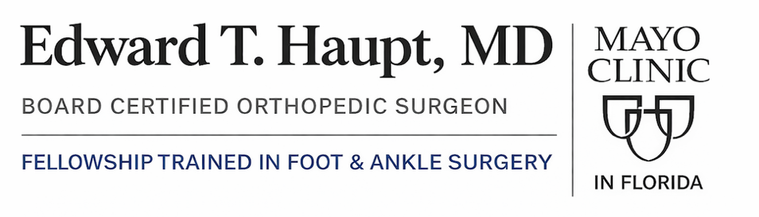


Mayo Clinic in Florida 4500 San Pablo Rd S, Jacksonville, FL, 32224 | Phone: 904-953-0853

Accelerated 2 Week Nonweightbearing Rehab Protocol For Osteotomy

Note: Progression through phases must be cleared by the orthopedic surgeon based on healing and stability.

Phase I: Early Protected Loading (Weeks 0 to 6)
Initial focus shifts from strict non-weightbearing to early progressive loading in a controlled environment.
Goal | Activity/Intervention | Notes & Progression
Protection & Immobilization | NWB to PWB Transition | Weeks 0-2: Strict NWB with crutches/scooter.  Weeks 2-4: Progress to 25-50% Weightbearing as tolerated in boot.  Weeks 4-6: Progress to 75% Weightbearing.
Immobilization | CAM Boot | Foot secured in a short-leg CAM boot full-time.
Healing & Pain Control | RICE Principles | Consistent elevation (above heart level) is critical to reduce swelling.
ROM & Maintenance | Active ROM | Gentle active plantarflexion/dorsiflexion; avoid inversion/eversion.
Conditioning | Proximal Strength | Maintain strength in non-operative leg, hips, and core. Upper Body Ergometer (UBE) permitted.

Phase II: Full Loading & Functional Gait (Weeks 6 to 10)
This phase aims to achieve full weightbearing and normalize the walking cycle earlier than the standard protocol.
Goal | Activity/Intervention | Notes & Progression
Weight Bearing | Full Weight Bearing (FWB) | Transition to 100% BWB in CAM boot by Week 6-8.
Gait Training | Normalizing Mechanics | Focus on heel-to-toe gait pattern with transition to a single crutch or cane as needed.
ROM | Full Ankle ROM | Restore full DF, PF, Inversion, and Eversion.
Early Strengthening | Isometrics & Bands | Progress to TheraBand resistance for all ankle planes.
Foot Mechanics | Intrinsic Strengthening | "Towel scrunches" and "marble pickups" to re-engage foot musculature.

Phase III: Dynamic Strengthening & Impact Prep (Weeks 10 to 16)
Moving out of the boot and into active stabilization.
- Footwear Transition: Wean from CAM boot into a rigid-soled athletic shoe (approx. Week 10).
- Proprioception: Begin static balance on one leg; progress to unstable surfaces (wobble board/balance pad).
- Closed-Chain Power: Bilateral and single-leg heel raises; progress to full squats and lunges.
- Conditioning: Increase intensity on elliptical and stationary cycling.

Phase IV: High-Level Return to Activity (Weeks 16+)
Final integration into running and sport-specific demands.
- Graduated Running: Begin walk-run program once pain-free and strength is nearly equal to the non-operative side.
- Agility: Progress from linear hopping to multi-directional drills (figure-eights, shuttle runs).
- Final Clearance: Requires formal orthopedic surgeon approval based on pain-free functional testing.

