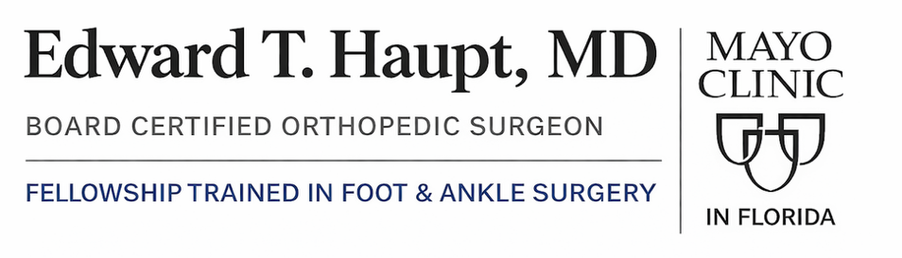


Mayo Clinic in Florida 4500 San Pablo Rd S, Jacksonville, FL, 32224 | Phone: 904-953-0853

Standard 6 Week Nonweightbearing Rehab Protocol For Osteotomy
Note: Progression through phases must be cleared by the orthopedic surgeon based on healing and stability.

Phase I: Maximum Protection (Weeks 0 to 6)
Goal | Activity/Intervention | Notes & Progression
Protection & Immobilization | Strict Non-Weight Bearing (NWB) | Use crutches, walker, or knee scooter. Zero weight on the operative foot to protect fixation.
 | Immobilization | Foot secured in a short-leg cast or CAM boot full-time.
Healing & Pain Control | RICE Principles | Consistent Elevation (above heart level) is critical to reduce swelling. Ice and Compression as needed.
ROM & Maintenance | Proximal Strengthening | Maintain strength in the non-operative leg, hips, and core.
 | Gentle Active ROM (Ankle/Toes) | Only if approved by the surgeon. Focus on plantarflexion/dorsiflexion only; avoid inversion/eversion.
 | Cardiovascular | Upper Body Ergometer (UBE) or stationary cycling if possible while maintaining strict NWB.

Phase II: Transition to Weight-Bearing & Early Strengthening (Approx. Weeks 6 to 12)
Goal | Activity/Intervention | Notes & Progression
Protection & Weight Bearing | Gradual Weight Bearing Progression (in CAM Boot) | Must have surgeon and X-ray clearance. Progression is slow:
 |  | * Week 6: Start at 25% body weight bearing (BWB).
 |  | * Week 7: Progress to 50% BWB.
 |  | * Week 8-12: Progress to 75% to Full Weight Bearing (FWB) as tolerated.
 | Gait Training | Focus on normalizing the walking pattern with support (crutches/cane).
Range of Motion (ROM) | Active & Gentle Passive ROM | Restore full ankle ROM (DF, PF, Inv, Ev). Avoid aggressive midfoot stress.
Strengthening | Ankle Isometrics & Resistance Bands | Progress to using resistance bands (TheraBand) for ankle strength.
 | Intrinsic Foot Muscles | Towel scrunches, marble pickups.
 | Closed-Chain (Low Load) | Seated calf raises, bilateral mini-squats (controlled by BWB status).
Cardiovascular/Conditioning | Low-Impact Activities | Stationary cycling (out of boot when FWB), elliptical machine (low resistance).

Phase III: Progressive Strengthening & Proprioception (Approx. Weeks 12 to 16+)
Goal | Activity/Intervention | Notes & Progression
Footwear Transition | Wean from CAM Boot | Transition to a rigid-soled, supportive athletic shoe, often with an orthotic.
Strength | Advanced Resistance Training | Increase resistance for ankle exercises. Progress machine-based training.
 | Functional Closed-Chain | Bilateral and then single-leg heel raises. Progressing to squats and lunges.
Balance (Proprioception) | Single-Leg Stability | Static balance, then progress to unstable surfaces (balance pad, wobble board).
Cardiovascular | Impact-Readiness | Increase intensity on elliptical/StairMaster. Pool running/swimming with kicking.
Hardware Removal (Optional) | Surgical Consideration | Often planned between 3 to 6 months. Requires a short period of modified weight bearing and recovery.

Phase IV: Return to Sport Specific Training (Approx. Weeks 16 - 24+)
Goal | Activity/Intervention | Notes & Progression
Return to Running | Graduated Run-Walk Program | Begin only when strength, ROM, and stability criteria are met (pain-free, equal strength). Progress to light jogging.
Agility & Plyometrics | Linear to Multi-Directional Drills | Progress from light hopping to agility drills like shuttle runs, figure-eights, and controlled cutting.
Power & Explosiveness | Sport-Specific Drills | Explosive plyometrics, jumping/landing mechanics, sport-specific movements (acceleration drills).
Full Sport Progression | Controlled Practice Reintegration | Gradual return to sport practice, starting with individual, then non-contact, then full-contact team drills.
Return to Play (RTP) | Final Clearance | Must receive formal, final clearance from the orthopedic surgeon based on full pain-free functional

