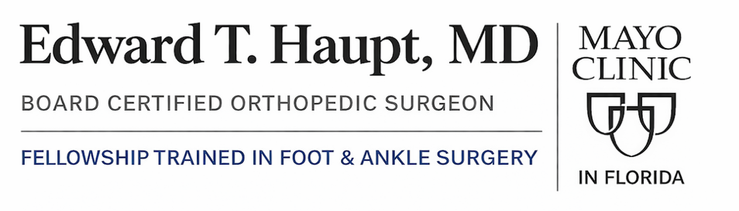


Mayo Clinic in Florida 4500 San Pablo Rd S, Jacksonville, FL, 32224 | Phone: 904-953-0853

Achilles Rehabilitation Protocol

Achilles Rupture Rehab times

Phase 1 | Protection (0-8 weeks)  0-2 weeks Non-Weight Bearing (NWB) in POP  2-4 weeks Partial Weight Bearing (PWB) in boot up to 50%  5 weeks Full weight bearing (FWB) in boot
Phase 2 | Early Mobilization (6-12 weeks)
Phase 3 | Strengthening (12- 20 weeks)
Phase 4 | Return to Activity (5-7 months)
Phase 5 | Return to play (8-12 months)

TREATMENT WEEK | TREATMENT PROCESS
Week 1  Rest and elevate the limb  Reduce Swelling and bruising  Non weight bearing (NWB) | Vacoped fixed on 30 ° with wedged sole. | Patient in Equinus (30° PF) POP
Week 2  Rest and elevate the limb  Reduce Swelling and bruising  NWB | Consider even up shoe raise on the unaffected limb Shower using the waterproof cover | Patient in Equinus (30° PF) POP
Week 3  Partial weight bear (PWB) up to 50% body weight in Vacoped  To wear Vacoped 24 hours a day (remove sole overnight must put back on next morning)  Avoid any DF stretches  Maintain Core and activity of non – affected joints | Vacoped fixed on 30°  Wear with wedged sole, wear 24hrs.  Physiotherapy to start | Gentle Soft tissue massage (scar, FHL, FDL Tib post tendons)  Under careful guidance start gentle active PF and gentle toes range of movement  No active or Passive DF above position held in the boot  Starts Quads, Hams and core strengthening
Week 4  PWB  Avoid any DF stretches  Maintain Core and activity of non – affected joints | Vacoped fixed 30 ° with wedged sole | Introduce gentle Passive and Active PF with Theraband  Avoid any DF or stretches until out of the boot  Increase gentle active exercises in PF position  (Seated heel raises, peroneals, toe flexors, invertors of the ankle)
Week 5  Avoid any DF stretches  Early active Rehab and limited  Fully weight bearing in Vacoped boot (FWB) | Vacoped fixed 30-20° with wedged sole | Continue with above NWB exercises by week 5 start to regain slowly Full PF, INV, EV  Aim for plantigrade by 5-6 weeks  Consider using Compex or alternative EMS (muscle stimulation)
Week 6  Avoid any DF stretche  Sleep can commence without Vacoped boot (usually around week 6)  FWB | Vacoped fixed 30-15° with wedged sole
Week 7  Avoid any DF stretches  FWB | Vacoped fixed 30-10° change to flat sole
Week 8  Avoid any DF stretches  FWB | Vacoped fixed 30-5° with flat sole | By Week 8 Start Proprioception/Balance work  Functional movements (squats, steps,)
Week 9  Avoid any DF stretches  FWB | Vacoped fixed 30-0° with flat sole | Continue as above exercises
Week 10  FWB in shoe  Avoid any DF stretches  WB Rehab progressing through to daily function and NWB sports  Continue to build strength, balance, proprioception and core | Discard Vacoped change to flat shoe with 1cm heel lift for 4 weeks use Vacoped outdoor | Gait re-education Ecc/Con loading (bilateral to single emphasis on Ecc phase) To start NWB aerobic- e.g. bike (push with heel not toes)
Week 11  FWB in shoe  Avoid any DF stretches | flat shoe with 1cm heel lift for 2/4 weeks. No Vacoped outdoors
Week 12  FWB in shoe | flat shoe with 1cm heel lift for 3/4 weeks | Gentle WB dorsiflexion stretch (Lunge position) be over cautious to avoid over stretching this phase of tendon remodelling
Week 13  FWB in shoe  Progressive exercise | flat shoe with 1cm heel lift for 4/4 weeks
Week 13-20  FWB no heel lift  Progress to Full Sports | WB in shoes without heel lift | Gentle return to Plyometrics to start forwards, backwards, directional, change of direction walking and progress as see fit
Red = strictly non weight bearing (NWB), Yellow = partial weight bearing in Vacoped (PWB), Orange = weight bearing as tolerated in Vacoped (WBAT), Green = fully weight bearing in normal shoe (FWB)

